Summer 1 New Life 2020
Key Stories |  | Key Bible Passages |  | Key Vocabulary
Easter Sunday  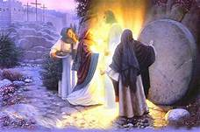  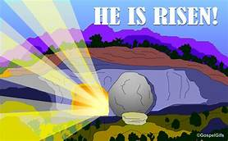 |  | (Mk 16:1-8). Jesus appears to Mary Magdalene  (Mk 16:1-8).Jesus appears to his disciples |  | Forgive  Friends  Love  Prayers  God  Pray  Peace  Risen
Prayer- Jesus said
Jesus said, ‘Peace be with you.’

 |  | Key Colours
 |  | Green – Ordinary Time
 |  | White or Gold- Christmas and Easter
 |  | Red – Celebrations and feast days
 |  | Purple – Advent and Lent
 |  | Key Ideas |  | Key Figures/ People
 |  | Early Early Learning Statements  (30-50/40-60 months)  Begin to understand that we celebrate Easter because Jesus rose from the dead.  Be aware that at Easter we celebrate Jesus is with us.  Know that Mary is Jesus’s mum, and our mum, too. Think of ways we can show Mary we love her.  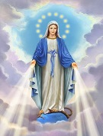 |  | God  Jesus  Disciples  Mary  Mary Magdalene
Songs
Sing a song sing a joyful song

Echo song:
Mother Mary, Mother Mary,

