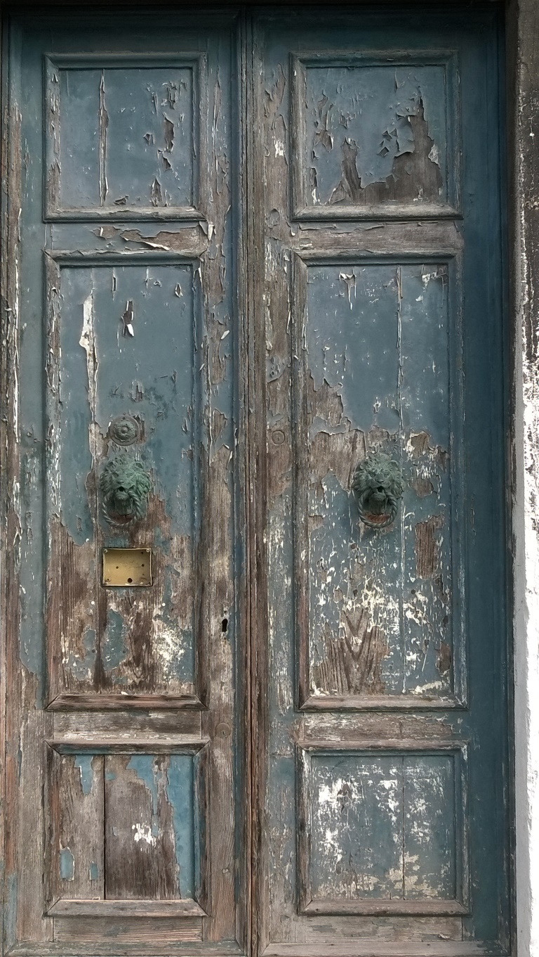
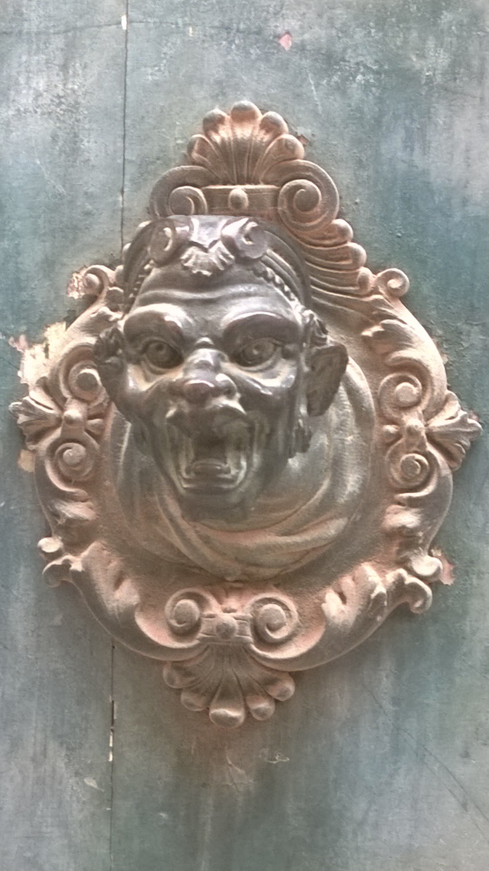
Writing prompt – 22nd April to the 24th April

These are a couple of pictures of doors and door knockers I took a few years ago on the island of Murano near Venice. Can you use them to help you write a short story? I always wondered what they might say if they came alive and what sort of magical world was on the other side of the door. Do you think they’d be giving you a warning or do you think they’d want you to come in? The one on the right looks like it might be a bit cheeky to me.
If you feel inspired, have a go a writing a short story. It could just be your conversation with the door knocker or perhaps you want to take you MC (main character) through the door and onto the other side. Most importantly, have fun with it and I’ll look forward to reading any stories anyone’s written when we return.
Mr Gould

