Year 6 Summer 1 – Electricity
Learning objectives for this topic | Key vocabulary | Useful websites to search for
To use recognised symbols when representing a simple circuit in a diagram  To associate the brightness of a lamp or volume of a buzzer.  To compare the reasons for variations in how components function.  Associate the brightness of a lamp or the volume of a buzzer with the number and voltage of cells used in the circuit.  Compare and give reasons for variations in how components function, including the brightness of bulbs, the loudness of buzzers and the on/off position of switches.  Use recognised symbols when representing a simple circuit in a diagram. | Battery – A container consisting of one or more cells where chemical energy is converted into electricity and used as a source of power  Bulb – A glass bulb which provides light by passing an electrical current through a filament  Buzzer – An electrical device that makes a buzzing noise and is used for signalling  Cell – A device containing electrodes that is used for generating current  Circuit – A complete and closed path around which a circulating electric current can flow  Conductor - A material or device which allows heat or electricity to carry through  Current – A flow of electricity which results from the ordered directional movement of electrically charged particles  Electricity – A form of energy resulting from the existence of charged particles  Filament – A conducting wire or thread with a high melting point that forms part of an electric bulb  Motor – A machine powered by electricity that supplies motive power for a vehicle or other moveable device  Switch – A device for making and breaking the connection in an electric circuit  Voltage – An electrical force that makes electricity move through a wire, measured in volts | www.coolkidfacts.com/electricity-facts  bbc bitesize
 |  | Key scientists and people
Andre Marie Ampere – invented the unit for measuring electrical current
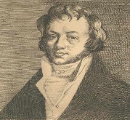

Alessandro Volta invented the electric battery.
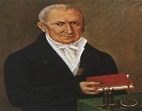

Benjamin Franklin discovered that lightening is electric.
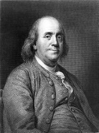
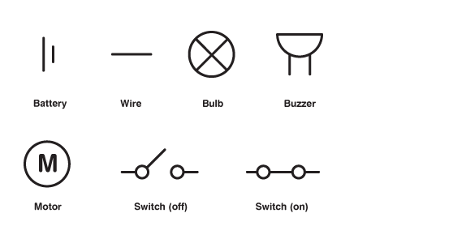
Components of a circuit

