Home learning week commencing 6th April 2020

Dear Parents/guardians,
I hope you and your families are keeping safe and well.
Below you will see some Easter activities that I have set for the children to do during this week. Most of the work that I have included is from Twinkle and links are attached so it is easy to access.
As normal there will be no work set during the Easter holidays. Enjoy your time together and celebrate Easter without worrying about work for the children.

If you haven’t already done so, sign up to Twinkle. During this time at home, Twinkle have offered free access to parents.
Go to https://www.twinkl.co.uk/offer. Register as a new member and type in the code UKTWINKLHELPS
Thank you for all your continual support and hard work at home,
Have a lovely Easter,
Mrs S Walker x

Hello lovely Year 1!
Another week done and hopefully you’re still enjoying your time at home and learning lots with your families.
As we head towards the Easter holidays, I have put together some lovely Easter activities that you can do this week.
Reading – Please make sure you are still reading as much as you can though. You have probably now read your two reading books that you took home from school. Just try and read a little bit each day from some of your favourite books at home. This will help you continue to get better and better!
Writing – Also, try and see if you can write a couple of sentences each day, remembering your capital letters and full stops. Make sure you continue to use your beautiful handwriting and you also have your handwriting book that you can use every day to practice your letters and size of letters.

Easter Activities
Year 1 Easter Egg competition
Although we are not in school we can still have our Easter egg competition. This is your chance to show off your beautiful, creative colouring skills. You can colour in the egg however you would like and bring it to school when we are back in. I will then choose the top 3 for an Easter treat! I know Easter will have passed, but we can still join in with the Easter fun
https://www.twinkl.co.uk/resource/t-t-5015-design-an-easter-egg-a4-worksheet

Easter egg basket
You will need somewhere to put all you little eggs won’t you? Try making and decorating this lovely Easter basket.
https://www.twinkl.co.uk/resource/t-c-254499-easter-themed-basket-craft

Mindfulness colouring
Just as we do in school it is important that we take some time to rest our minds and have some quiet time. One way we do this is through mindfulness colouring. There are lots of different sheets for you to choose from here.
https://www.twinkl.co.uk/resource/t-t-26544-easter-egg-mindfulness-colouring-sheets

Maths Easter Booklet
To keep our mathematical minds active, try and have a go at the Easter Maths booklet. There are lots of fun questions for you to tackle and colour in afterwards.
https://www.twinkl.co.uk/resource/t-t-17242-easter-themed-maths-activity-book

The Easter Story

At St. Peter’s the Easter story is very important to our us and our faith. We learn about how Jesus died on the cross for us and we celebrate when he rose again on Sunday Easter. With the help of someone in your family you can read all about the Easter story using the powerpoint below.
https://www.twinkl.co.uk/resource/t-t-5074-the-easter-story-powerpoint

Try putting the story in the correct order and writing a sentence about each picture. We have done lots of times in school so you should remember how we set it out.
Remember your capital letters, full tops and to use your beautiful handwriting!
https://www.twinkl.co.uk/resource/t-t-19563-easter-story-sequencing-shortened-8-cards

There is also an Easter flap book which you could make and colour.
https://www.twinkl.co.uk/resource/t-t-17573-easter-story-writing-flap-book

My Easter bunny adventure story.
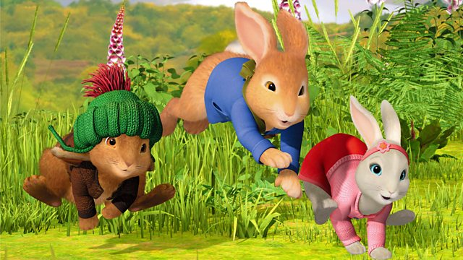

Can you see the picture of the three little bunnies about to start their adventure?
I’d like you to try and write a fantastic story about the adventures that they have! Think about what the bunnies are called, where they live and what they are going to get up to.
Remember the story must have a beginning, a middle and an end. Remember your capital letters, full stops and beautiful handwriting. Try and add a couple of ‘and’s in there and a ‘because’ and if you want to make it really wonderful use lots of adjectives.

I hope this keeps you nice and busy. Have a lovely Easter and enjoy all your delicious Easter eggs!
Take care and we will see you soon.
Love from Mrs Walker and Mrs Green x

