Home Learning Week 3
Hi everyone,
I hope you have had a good week of home learning last week. This week is a very special time in our religious calender as it is Holy Week.
It is a time for thinking about the events that led to Jesus sacrificing his life for us. We need to remember the events of the Last Supper, Jesus’s arrest in the Garden of Gethsemane, his crucifixion and Jesus rising from the dead.
It is a time to reflect and pray for each other at this Easter time. I have included a pack to follow the Easter Story.
Task 1
https://www.twinkl.co.uk/resource/tp2-r-052-planit-re-year-3-good-friday-lesson-1-the-easter-story-lesson-pack
Celebrating Easter
New Life
Winter is over
The world is waking up
From its deep sleep.
The bare tree is now clothed, the daffodil raises its golden head,
The sharp wind is conquered by the gentle breeze.

Once again, the creator
has restored life to a sleeping world.
Task 2
Read the poem above and answer the following questions.
What signs of new life in spring are in the poem?
Wat other signs of new life have you noticed in springtime?
Make a list of all the things you enjoy about springtime.
Who do you think the ‘Creator’ in the poem is meant to be?
Explain the last two lines of the poem in your own words.

Task 3
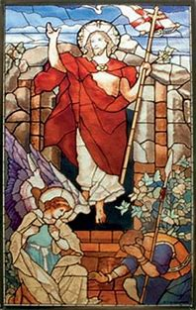
Take a minute to look at the resurrection picture, then write a short prayer, about five lines, describing the wonderful moment when Jesus rose from the dead. Begin and end your prayer with ‘ALLELUIA!’

Easter Activities
Mystery Maths Easter problem solving.
https://www.twinkl.co.uk/resource/t2-t-16473-lks2-easter-mystery-maths-game

https://www.twinkl.co.uk/resource/year-3-spring-activity-booklet-english-t2-e-5097

https://www.twinkl.co.uk/resource/t-t-26544-easter-egg-mindfulness-colouring-sheets

Have a lovely Easter Year 3
Mrs Warran and Mrs McWiggan

