Year 4 Home Learning

**Science**

This half term our topic has been teeth and digestion. We have learned a lot about teeth however we have only just started work on The Digestive System.

If you feel like getting messy, have a go at this:

<https://www.bbc.co.uk/bitesize/topics/zf339j6/articles/zrm48mn>

Can you research ‘The Digestive System’ and create an information leaflet or poster about how the digestive system works. Maybe you could title it; ‘From chewing to pooing!’

**RE**

Continue our promise of saying an extra prayer every day for Lent.

Find out about the rest of the Holy Week Events (Good Friday, Easter Sunday). Maybe you could create your own Easter garden? Take some pictures if you can!

**Daily Reading**

We still expect you to read as much as you can! Try to read something every day. This can be your reading book from school, a good book that you have at home, a new book from our Year 4 book list, a comic book or a magazine. Whatever you read, keep a list and get an adult to sign it – we will see who has read the most when you return to school!

We would also love some book reviews to display in our library or our class reading area, so I have attached a book review template that you could complete.

**Writing**

The events taking place in our world at the moment will, in future, become a historical event.

Could you keep a diary for what activities you do/ what happens on each day and your thoughts/feelings?

In years to come, you could read back your diaries and remember. And you never know, your diaries could be used to teach people in the future about what happened, or it could even become a bestseller!!

**Twitter**

If adults would like to share any photos of home learning with us, feel free to tag our Twitter page @stpetersSB. We would love to see them!

**Maths**

*Times Tables Rock Stars*

* Try to practice your times tables daily.
* I have set up some Garage, Studio and Soundcheck sessions and some battles for you to take part in. See if you can beat the goals set and your opponents! Remember you can also invite your friends to a ‘Rock Slam’!

*Twinkl Spring Themed Home Learning Maths Booklet*

* This includes many activities focusing on many different areas of maths.

*Area and Perimeter*

* These are the topics we would have studied over the next couple of weeks. See the information sheet attached and have a go at the worksheets.

**DT**

We would have been making ‘Cheese Flan’ as part of our food technology. How about asking an adult to help you bake one? Will it be as good as Zoe’s? Or, an adult could teach you to cook something else. Please take any photos or write down your recipes for us to share.

**Art/History**

Can you create an Anglo-Saxon brooch using foil?

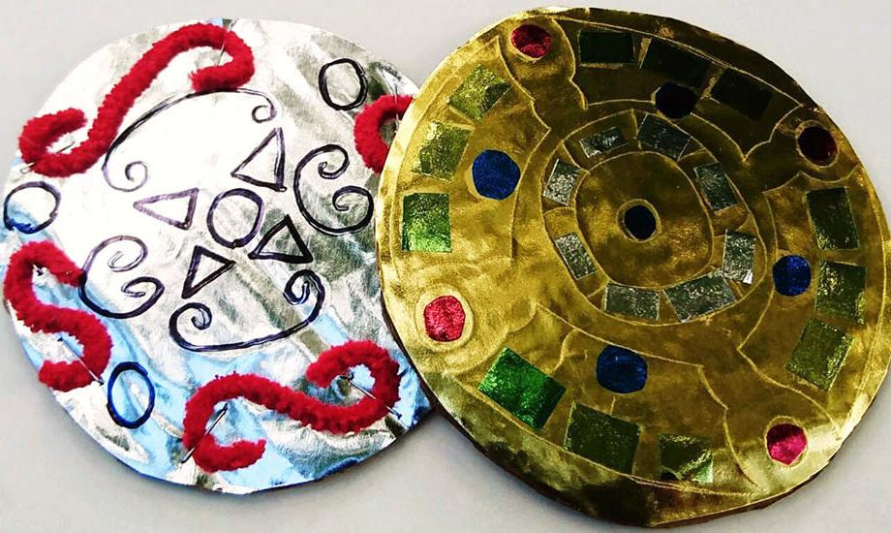

*Dear Parents,*

*Here is an overview of some tasks the children could complete at home over the forthcoming days/weeks. At St. Peter’s we are committed to ensuring that your child is still learning as much as possible and endeavour to do our absolute best to keep this happening.*

*Thank you for your ongoing support over the year and at this time. I wish you, your families and friends all the best.*

*Kindest regards,*

*Mrs Cooke*