Reading books:
I am aware that even though we sent two reading books home with the children, a lot of them will now be ready for a new book. Therefore, I have created a login for our class on the Oxford Reading Tree website. Please follow the steps below to access a set of eBooks that match your child’s book band.
Please record any books completed in your child’s reading record. I do ask you to please refrain from ‘trying’ your child on the next book band until they are ready as this will only cause confusion and could be stressful for your child. It is important that they have fluently read all the eBooks in their current book band and can accurately recall the story/facts to you and answer questions on the text before they move on.
By using this resource alongside the ‘Teach Your Monster to Read’ app and reading your own books at home – I hope the children will continue to frequently read at home and develop their love of books and reading.
Thank you for your continued support, love Mrs Russell

- Go to the website - www.oxfordowl.co.uk
Click ‘My Class Login’ and then enter the username (stpetersyear2) and password (Paddington).

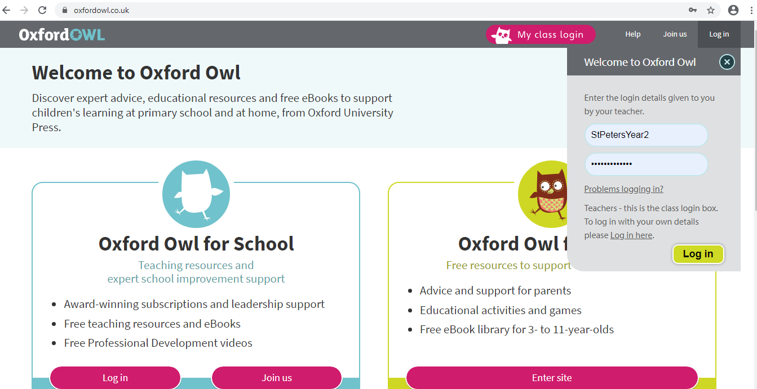
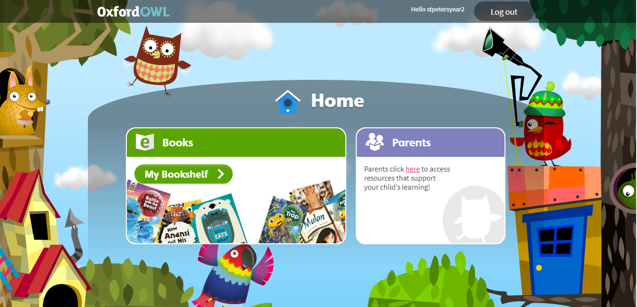
- Click on the parent tab.

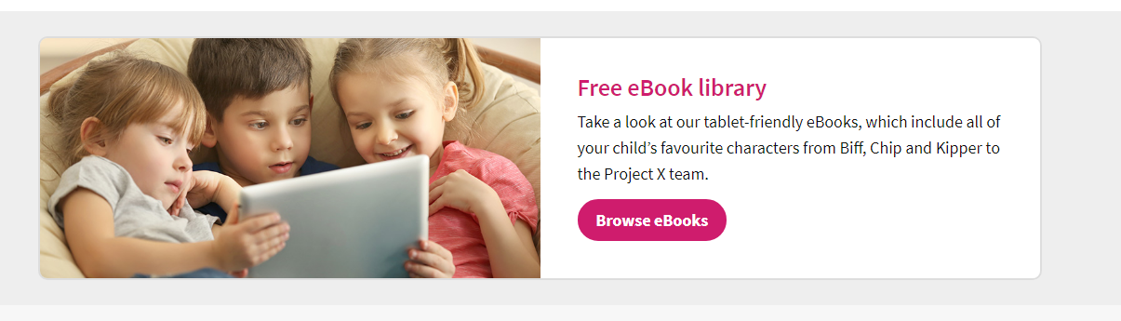
- Click to browse the eBooks.

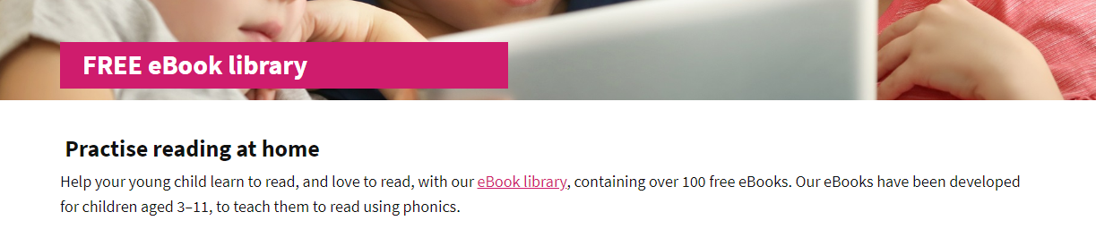
- Click on the eBook library.

- Click on the levels tab to select your child’s book band.
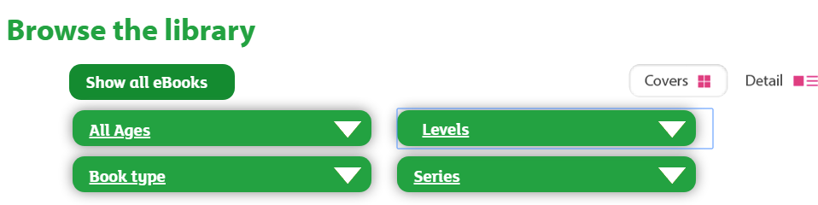
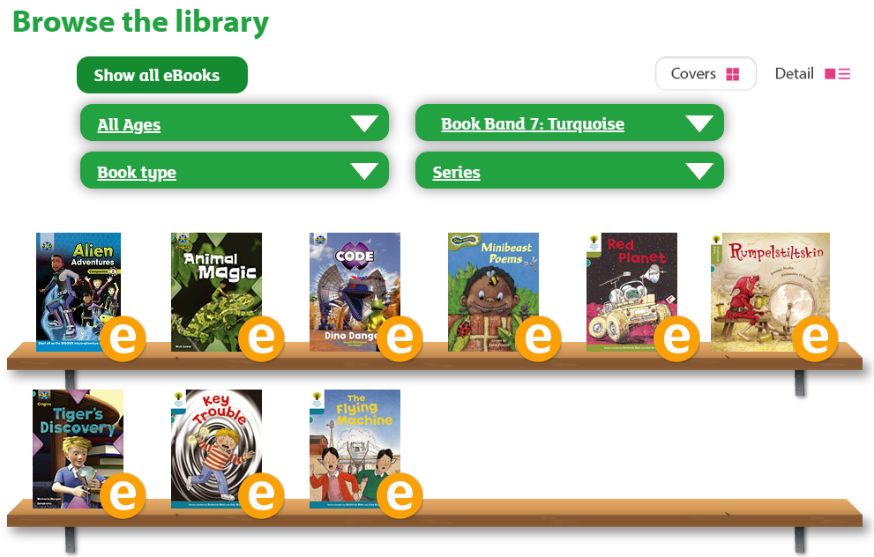
- Select your child’s book band (there will be a coloured sticker or tab on their independent reading book).

- Enjoy reading and remember to record all books read in your child’s reading record.

Thank you!

