Peter is sorry – can you remember why? Tell the story to an adult at home.
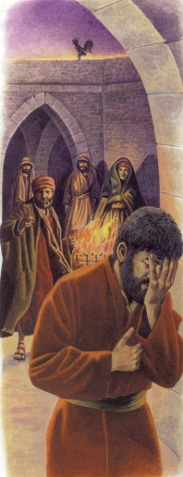

“Open our eyes to see, open our ears to hear, open our lives to live your calling, open us, Lord, to love.”

It was night time.
Jesus and his disciples were in the garden.
Lots of people were coming – coming to take Jesus away. Some of them
were soldiers. They held on to Jesus and took him away.
Nearly all the disciple friends ran away, but Peter crept behind the soldiers and saw where they took Jesus.
Then a girl saw Peter!
“You’re Jesus’ friend, aren’t you?” she said.
“No, I’m not,” said Peter.
Later, some other people saw Peter.
“You know Jesus, don’t you?” they said.
“No, I don’t,” said Peter.
When it was nearly morning, someone else spoke to Peter.
“You’re definitely one of Jesus’ friends.”
“No! I am not,”said Peter.
Just at that moment, Jesus turned round and looked
straight at Peter. The cockerel crowed three times. “Cock a doodle-doo!”
Peter knew he had done the wrong thing. He had pretended not to know Jesus.
He was very sorry.
Jesus forgave him.
The gospel of the Lord.
We say, “Praise to you, Lord Jesus Christ.”

