

ST PETER’S CATHOLIC PRIMARY SCHOOL 
NURSERY ADMISSION POLICY 2020 - 2021

St Peter’s Catholic Primary School was founded by the Catholic Church to provide education for children of Catholic families. Whenever there are more applications than places available, priority will be given to Catholic children in accordance with the oversubscription criteria listed below. The school is conducted by its governing body as part of the Catholic Church in accordance with its trust deed and [instrument of government] [articles of association], and seeks at all times to be a witness to Our Lord Jesus Christ.
As a Catholic school, we aim to provide a Catholic education for all our pupils. At a Catholic school, Catholic doctrine and practice permeate every aspect of the school’s activity. It is essential that the Catholic character of the school’s education be fully supported by all families in the school. We therefore hope that all parents will give their full, unreserved and positive support for the aims and ethos of the school. This does not affect the right of an applicant who is not Catholic to apply for and be admitted to a place at the school in accordance with the admission arrangements.
The governing body will, where logistically possible, admit twins and all siblings from multiple births where one of the children is the last child ranked within the school’s Published Admissions Number (“PAN”).

Pupils with an Education, Health and Care Plan (see note 1)
The admission of pupils with an Education, Health and Care Plan is dealt with by a completely separate procedure. Children with a, Health and Care Plan that names the school must be admitted. Where this takes place before the allocation of places under these arrangements this will reduce the number of places available to other children.

For the school year commencing September 2020 the Governing Body has set its admissions number at 26. Admissions will take place in September and January, if there are places available following the September admission.

Oversubscription Criteria
Where there are more applications for places than the number of places available, places will be offered according to the following order of priority.
- Catholic looked after and previously looked after children. (see notes 1&2)
- Catholic children who are resident in the parish of Ss Peter & Raphael. (see notes 2&11)
- Other Catholic children. (see note 2)
- Other looked after and previously looked after children. (see note 1)
- Catechumens and members of an Eastern Christian Church. (see notes 3&4)
- Children of other Christian denominations whose membership is evidenced by a minister of religion. (see note 5)
- Children of other faiths whose membership is evidenced by a religious leader. (see note 6)
- Any other children.
Within each of the categories listed above, the following provisions will be applied in the following order.
- The attendance of a brother or sister at the school at the time of enrolment will increase the priority of an application within each category so that the application will be placed at the top of the category in which the application is made after children in (1) above (see note 8).
- The children of staff will be given increased priority within each category so that the application will be placed at the top of the category in which the application is made after children in (1) above (see note 10).

Tie Break
Priority will be given to children living closest to the school determined by the shortest distance. Distance will be measured as a straight line from the child’s home address, using the address point assigned by the National Land and Property Gazetteer, to the main gate to the school property. Measurements will be made using the local authority’s school admissions data mapping software, which uses a Geographical Information System based on Ordnance Survey.

For categories 1-5, a valid certificate of Catholic baptism is required to establish the faith of the child. We also require proof of address to confirm residency of parish. This proof must be supplied to school before the meetings to allocate places. Priority cannot be given to children without this supplementary information.

Proof of birth is needed to establish child’s age. This must be supplied to school before the meetings to allocate places.

Meetings will take place January 2020 prior to admission in September 2020 and admission in January 2021.

Offer letters for admission Sep 2020 and Jan 2021 will be sent Jan 2019

Notes

- A Looked After Child is a child who is (a) in the care of a Local Authority, or (b) being provided with accommodation by a Local Authority in the exercise of their Social Services functions (under section 22(1) of the Children Act 1989). A previously Looked After Child is one who immediately moved on from that status after becoming subject to an adoption, residence or special guardianship order.

- Catholic’ means a member of a Church in full communion with the See of Rome. This includes the Eastern Catholic Churches. This will normally be evidenced by a certificate of baptism in a Catholic Church or a certificate of reception into the full communion of the Catholic Church. For the purposes of this policy, it includes a looked after child who is part of a Catholic family where a letter from a priest demonstrates that the child would have been baptised or received if it were not for their status as a looked after child (e.g. a looked after child in the process of adoption by a Catholic family).
For a child to be treated as Catholic, evidence of Catholic baptism or reception into the Church will be required. Those who have difficulty obtaining written evidence of baptism should contact their Parish Priest [who, after consulting with the Diocese, will decide how the question of baptism is to be resolved and how written evidence is to be produced in accordance with the law of the Church].
Baptismal certificates must be forwarded to the school by 15th January 2020.

- catechumen’ means a member of the catechumenate of a Catholic Church. This will normally be evidenced by a certificate of reception into the order of catechumens.
- ‘Eastern Christian Church’ includes Orthodox Churches, and is normally evidenced by a certificate of baptism or reception from the authorities of that Church.
- “children of other Christian denominations” means children who belong to other churches and ecclesial communities which, acknowledge God’s revelation in Christ, confess the Lord Jesus Christ as God and Saviour according to the Scriptures, and, in obedience to God’s will and in the power of the Holy Spirit commit themselves: to seek a deepening of their communion with Christ and with one another in the Church, which is his body; and to fulfil their mission to proclaim the Gospel by common witness and service in the world to the glory of the one God, Father, Son and Holy Spirit. An ecclesial community which on principle has no credal statements in its tradition, is included if it manifests faith in Christ as witnessed to in the Scriptures and is committed to working in the spirit of the above.
All members of Churches Together in England and CYTÛN are deemed to be included in the above definition, as are all other churches and ecclesial communities that are in membership of any local Churches Together Group (by whatever title) on the above basis.
- “children of other faiths” means children who are members of a religious community that does not fall within the definition of ‘other Christian denominations’ at 6 above and which falls within the definition of a religion for the purposes of charity law. The Charities Act 2011 defines religion to include:
- A religion which involves belief in more than one God, and
- A religion which does not involve belief in a God.
Case law has identified certain characteristics which describe the meaning of religion for the purposes of charity law, which are characterised by a belief in a supreme being and an expression of belief in that supreme being through worship.

- The Headteacher will maintain a list of pupils whose parents have requested a place in Nursery.

- Where a child lives with parents with shared responsibility, each for part of a week, the home address is the address from which the child travels to school for the majority of school days per week. If the number of days is exactly equal the home address will be that of the parent who receives the Child Benefit

- Children entering the Nursery will not automatically be offered a place in the Reception Class. The admissions criteria for admission to school will still apply.

- Sibling is defined as a brother or sister, half brother or sister, adopted brother or sister, step brother or sister, or the child of the parent/carer’s partner where the child for whom the school place is sought is living in the same family unit at the same address as that sibling.

- The Governing Body reserves the right to withdraw the offer of a nursery place where false evidence is received in relation to baptism, sibling connections or place of residence.

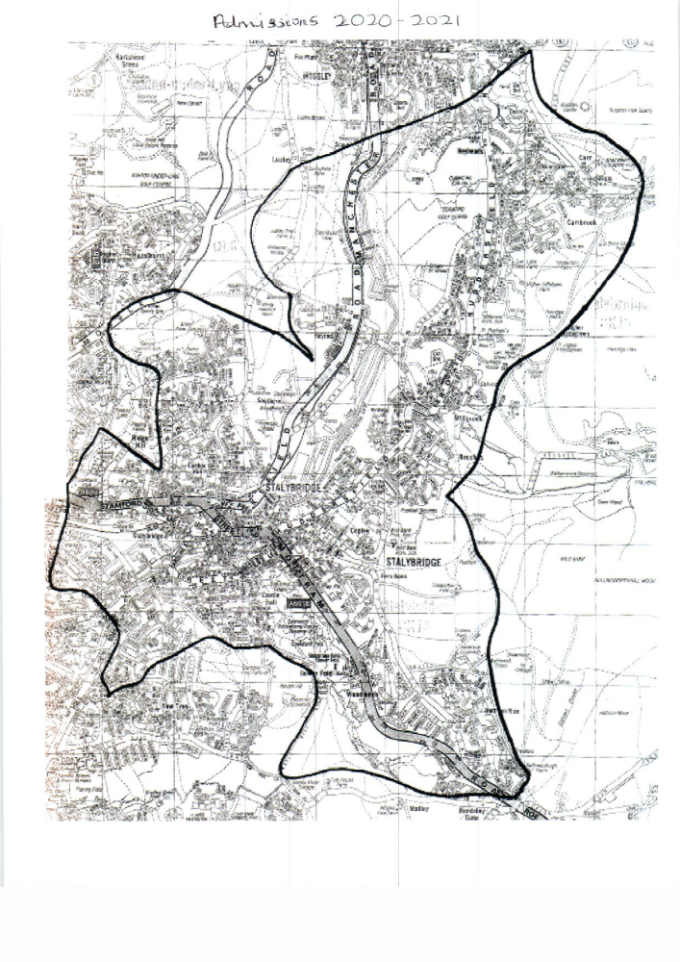

ST PETER’S CATHOLIC PRIMARY
SUPPLEMEMTARY INFORMATION REQUIRED FOR ADMISSION TO SCHOOL 2020 – 2021

- For a child to be treated as Catholic, evidence of Catholic baptism or reception into the Church will be required. Those who have difficulty obtaining written evidence of baptism should contact their Parish Priest

- Baptismal certificates must be forwarded to the school by the closing date – 15th January 2020

- The address from which distance will be measured will be the permanent residential address, at the time of the closing date of application, of the parent with whom the child is normally resident. Where a child lives with parents with shared responsibility, each for part of a week, the home address is the address from which the child travels to school for the majority of school days per week. If the number of days is exactly equal the home address will be that of the parent who receives the Child Benefit

- Parents are asked to provide TWO documents from the list below as proof of address:
- Mortgage statement*
- Tenancy Agreement or letter from landlord*
- Council Tax statement*
- Benefit statements*
- Recent utility bill (gas, electricity, land-line phone bill but not a mobile phone bill)**
- Current TV Licence
- Letter from a solicitor confirming exchange of contracts on a residence**
(* issued within last 12 months ** issued within last 3 months)

Please note school will contact the LA and other services for any applicant where school needs further proof.

Include for a Catholic voluntary aided school and delete for a Catholic voluntary academy
Include for a Catholic voluntary academy and delete for a Catholic voluntary aided school

