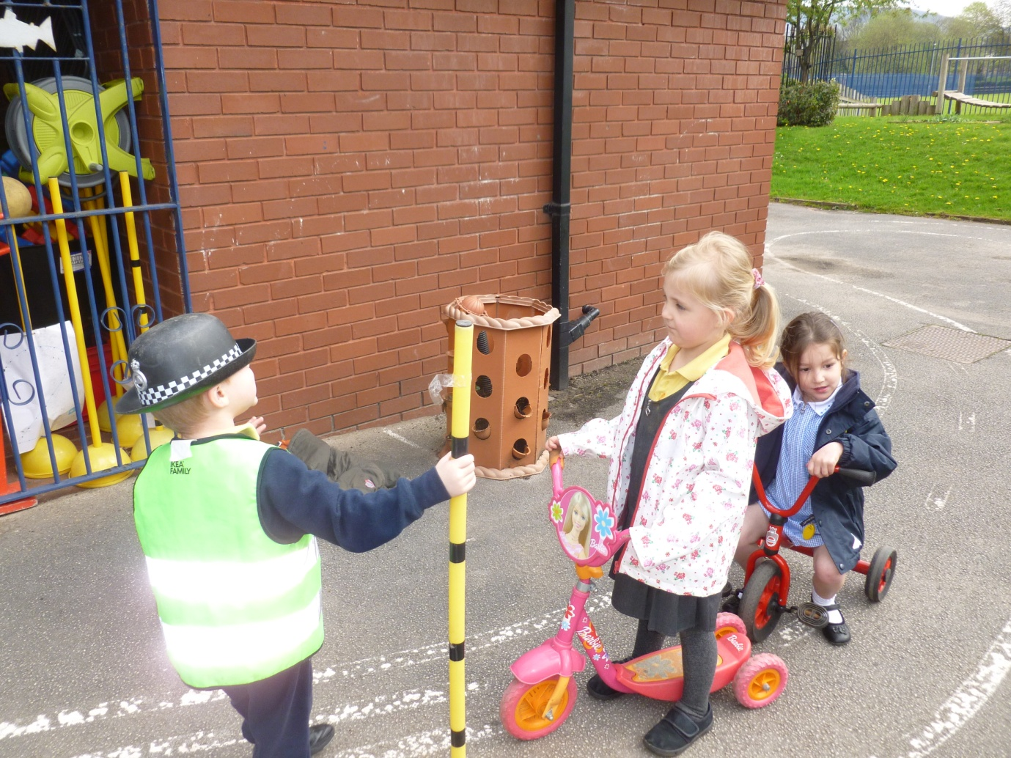
We enjoyed some role play outdoors, learning about crossing the road safely. We learned that we must always hold an adult’s hand in the road. Here, one of us is pretending to be a lollipop person, standing on our zebra crossing. On our welly walks, we take turns to press the button on the pelican crossing, and we look and listen for traffic. Mrs. Worrall is the lollipop person on our welly walks!

