Spring 1 The Holy Family
Key Stories |  | Key Bible Passages |  | Key Vocabulary
Jesus is presented in the Temple  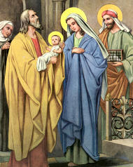  The Good Samaritan  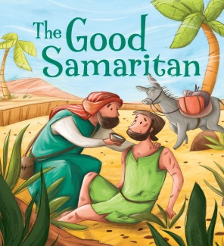 |  | Jesus is presented in the Temple (Lk 2:22-32).  Loss and finding of Jesus (Lk. 2: 41-50).  Jesus and the children (Matt 19:13-15).  Parable of the Good Samaritan (Lk. 10:29-37). |  | Temple | Samaritan
 |  | Prayer- Dear Jesus  Help us to be kind like you.  Please help us to be kind and helpful at home and at school. |  | Love | Prayers
 |  | Key Colours |  | Help | Pray
 |  | Green – Ordinary Time |  | Family | Reflect
 |  | White or Gold- Christmas and Easter
 |  | Red – Celebrations and feast days
 |  | Purple – Advent and Lent
 |  | Key Ideas |  | Key Figures/ People
 |  | • Children know that Mary is the Mother of Jesus.  • They come to appreciate their friendship with Jesus.  • They come to know that Jesus helps us to choose the good.  • Children are able to join in simple prayers and hymns.  • They learn to respect each other and respect adults. |  | God  Simeon  Anna  Mary  Joseph  Jesus
 |  | Early Early Learning Statements  (30-50/40-60 months)  • Know that Mary and Joseph took Jesus to the Temple.  • Know about the loss and finding of Jesus.  • Know that Jesus loves little children.  • Know about the parable of the Good Samaritan.  􂿞Try to be a Good Samaritan to others. |  | Jesus
Songs
When Jesus was a little boy’
‘Jesus is my Best Friend’,
Jesus Loves the Little Children

