Year 6 Autumn 1 The Kingdom is for All
Key Stories | Key Bible Passages | Key Vocabulary
The Prodigal Son  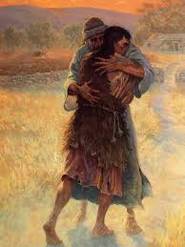  The Good Samaritan  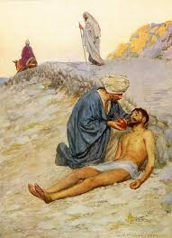  The Rich man and Lazarus 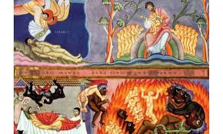  The Miracles of Jesus  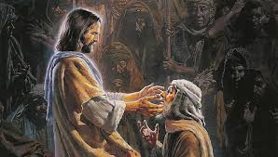 | Lk 15:4-6 The Parable of the Lost sheep  Lk 15:8-10 The Parable of The Lost Drachma  Lk15:11-32 The Prodigal Son  Lk 10:29-37 The Good Samaritan  Jn 13:34 A New Commandment  Matt 25:34-37  Jn 10:10-11 I come so that you may have life  Luke 16:19-31 The Rich Man and Lazarus  Luke 14:16-24 Invited guests who make excuses  Mk:1-10 The Miracles | confirmation, condemn, Pharisees, scribes, Kingdom values, paradise, The Law, banquet, possessions, grace  justice, talents, freedom, to witness, inspirational, mission
 | Key Colours
 | Green – Ordinary Time
 | White or Gold- Christmas and Easter
 | Red – Celebrations and feast days
 | Purple – Advent and Lent
 | Key Ideas | Key Figures/ People
 | - Everyone is invited to the Kingdom of God  - How we can show our commitment to the Kingdom  - The New Commandment  - How we can respond to the Kingdom  - The Miracles: How Jesus showed compassion  - Inspirational people who helped spread the Kingdom of God | Jesus  Ourselves  St Therese of Lisieux

