Year 5 Spring 1 Art – Sketching and drawing – the work of M C Escher
Learning objectives for this topic | Key vocabulary | Key artists
To create sketch books to record observations.  To improve mastery of art and design techniques including drawing.  To improve understanding of rendering shapes. | Mannequin  Portrait  Pressure  Rendering  Self-portrait  Shading  Sketching  Tone  Texture | M C Escher  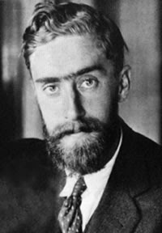  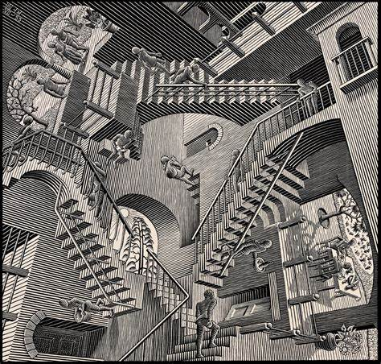
Art Skills Covered
Skills- Drawing

Elements- Texture, line, shape, tone, form and space

