Year 6 Autumn 2 – Animals including humans
Learning objectives for this topic | Key vocabulary | Useful websites to search for
To Identify and name the main parts of the human circulatory system, and describe the functions of the heart, blood vessels and blood.  To help learn about the structure of real organs, through watching the teacher carry out a dissection.  To help develop observational skills, through investigating a dissected organ (heart).  To know that blood is an important transport system in my body.  To know that my blood passes through the heart twice during each circulation (double circulation).  To know that the blood collects oxygen from the lungs and in exchange gets rid of carbon dioxide (respiration).  To Describe the structure of the lungs.  To explain what happens when we breathe in and out.  To understand why exercise is important for my health.  To explain what I need to keep my body healthy.  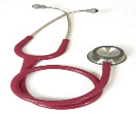  To recognise the impact of diet, exercise, drugs and lifestyle on the way their bodies function. | Arteries – Muscular-walled tubes that transport blood from the heart to other parts of the body  Blood – Red liquid that circulates in arteries and veins, carrying oxygen to and carbon dioxide from tissues of the body  Blood vessel – A tubular structure carrying blood through the tissues and organs  Circulatory system – The system that circulates blood through the body, including the heart, blood vessels and blood  Heart – A hollow muscular organ that pumps the blood through the circulatory system  Lungs – Pair of organs situated within the ribcage where oxygen can pass into the blood and carbon dioxide be removed  Muscles – A band or bundle of fibrous tissues that have the ability to contract, producing movement in or maintaining positions of parts of the body  Nutrients – A substance that provides nourishment essential for the maintenance of life and for growth  Organs – Part of an organism that is typically self-contained and has a specific vital function (e.g. the heart and lungs)  Veins – Tubes forming part of the blood circulation system of the body, carrying mainly oxygen-depleted blood towards the heart | SMM.org/heart  BBC Bitesize
 |  | Key scientists and people
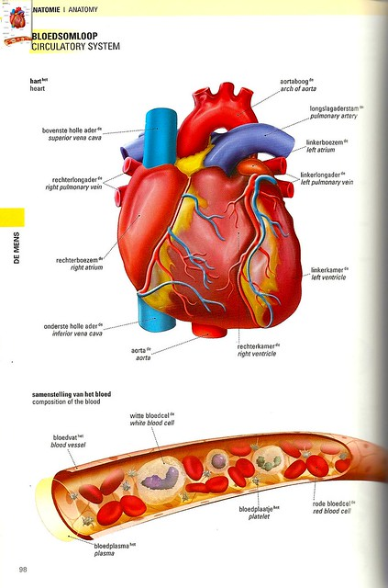
This Photo by Unknown Author is licensed under CC BY-NC
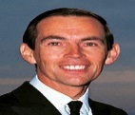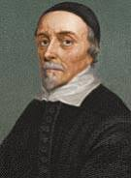
Dr Christian Barnard.
William Harvey

