Year 2 Autumn 2 History
Learning objectives for this topic | Key vocabulary | Useful websites to search for
To understand why the plague broke out and why it spread.  To compare living conditions in the past and present.  To compare role of doctors in the past and the present.  To describe living conditions in the past.  To learn about and empathise with Samuel Pepys.  To list main events chronological order.  To record answers to key questions regarding the fire, after reading and discussion.  To compare fire services past and present | Plague – dangerous disease from the past.  Black death – common name for Bubonic Plague.  Population – number of people who live in a place.  Pudding Lane – where the Great Fire of London started.  King Charles 2nd – monarch at the time of the Great Fire of London.  Samuel Pepys – a man who lived during the Great Fire of London and wrote a diary.  Diary – daily record of events.  St Paul’s Cathedral – one of London’s big and important churches. | bbc.co.uk – bitesize KS1  fireoflondon.org
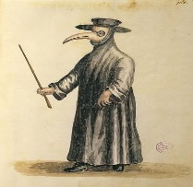

Plague Doctor
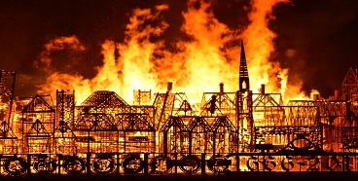

Great Fire of London

