God’s Great Plan
Key Stories |  | Key Bible Passages |  | Key Vocabulary
Story of creation  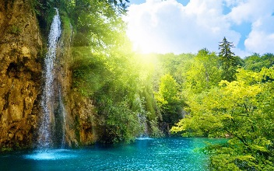  Adam and Eve  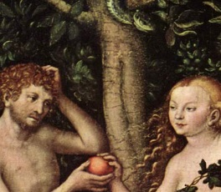  Noah’s Ark  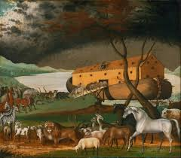 |  | Psalm 104  Gen.1:14-31 Story of Creation  The Fall Gen.3:1-19  Gen.6:13-22 Noah’s Ark |  | Creation | Beautiful
 |  | Key Colours |  | World | Love
 |  | Green – Ordinary Time |  | Help | choices
 |  | White or Gold- Christmas and Easter
 |  | Red – Celebrations and feast days
 |  | Purple – Advent and Lent
 |  | Key Ideas |  | Key Figures/ People
 |  | Be aware of the beauty of God’s World |  | God
 |  | What the story of Creation means |  | Adam
 |  | The first people were Adam and Eve, who made some wrong choices. |  | Eve
 |  | Think about promise and hope. |  | Noah and his ark

