Getting to Know Jesus (Reception RE: Spring 1)
Key Stories |  | Key Bible Passages |  | Key Vocabulary and Songs
*The Finding in the Temple  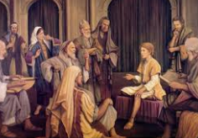  *The First Disciples (cast out your nets to the other side)  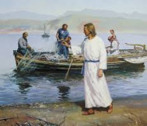  *Jesus loves all children  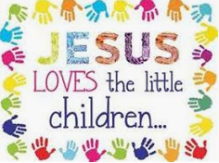 |  | Luke 2: 41-52 (The Finding in the Temple)  Luke 5: 1-11 (The First Disciples)  Matt 19: 13-15 (Jesus loves all children)  John 5: 1-15 (The man healed at the pool) |  | Come and go with me, to my Father’s house | Follow Me
 |  | Key Colours |  | temple | God’s work
 |  | Green – Ordinary Time |  | disciple friends | love – Jesus loves all of us
 |  | White or Gold- Christmas and Easter
 |  | Red – Celebrations and feast days |  | heal, help, make better
 |  | Purple – Advent and Lent
 |  | Key Ideas |  | Key Figures/ People
 |  | Know about the loss and finding of Jesus in the temple. Reflect on the meaning of this event for Mary and Joseph. |  | Jesus - as a little boy
 |  | Know that Jesus chose disciple friends to help Him. Be aware that Jesus wants us to help Him. |  | Jesus – grown into a man
 |  | Know that Jesus has great love for each one of us. Think of ways to show our love for Jesus. |  | 12 disciples
 |  | Know that Jesus healed a man at the pool of Bethesda. Reflect on how Jesus can help us. |  | the man at the pool, to whom Jesus said, “Take up your bed and walk.”

