Year 5 Autumn 1 Creation
Key Stories | Key Bible Passages | Key Vocabulary
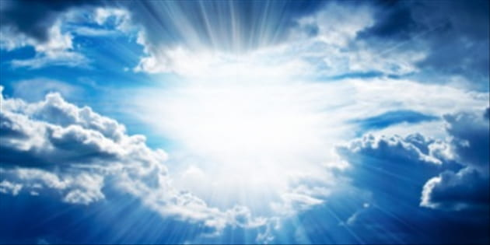  The Creation Story  The Fall  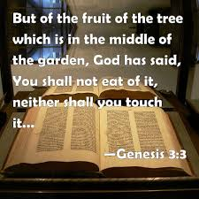 | The first creation story (Genesis 1:1-31)  The second creation story (Genesis 2: 5-25)  The story of the Fall (Genesis 3)  The King will judge all people (Matthew 25:35-40) | womb, mysteries, image and likeness, immortal soul, spiritual, bidding prayers, stewards, stewardship, natural, man-made  dignity, respect, responsibility, ecosystem, resources, diversity, ecological lifestyle, vulnerable, refugee, compassion, workhouse, canonize
 | Key Colours
 | Green – Ordinary Time
 | White or Gold- Christmas and Easter
 | Red – Celebrations and feast days
 | Purple – Advent and Lent
 | Key Ideas | Key Figures/ People
 | - We are created in the image and likeness of God.  - God calls us to care for each other and all creation with love and respect.  - There are times when we fail to be good stewards of creation.  - There are people who show great respect the weakest members of society and have great respect for creation. | God, Adam, Eve, Pope Francis, St Francis of Assisi, St Vincent de Paul

