Year 4 Autumn 2 History – The Romans
Learning objectives for this topic | Key vocabulary | Key places and people
To understand the terms ‘invade’ and ‘settle’ and to place the Romans on a timeline.  To find out who was in Britain when the Romans invaded and learn about their way of life.  To find out about the Roman way of life.  To find out why the Romans invaded Britain.  To explore who Boudicca was from different points of view.  To find out what survived from the Roman settlement of Britain. | Invade  Settle  Settlement  Britain  Celts  Romans  Technology  Religion  Art  Towns  Home and family  Farming  Army weapons  Shields  Armour  Revolt  Army Formations  Square  Tortoise  Pigs head/Arrow | Romans  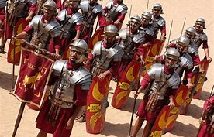  Celts  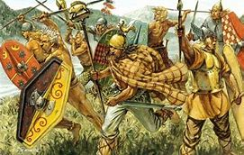  Boudicca  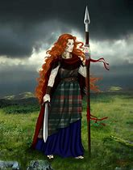  England  Italy  Rome
Key learning questions
What do these words mean? Can we demonstrate this?

Who were the Celts?

What was Roman life like? How was it different to the Celt way of life and our way of life.

Why was the Roman army so powerful? Would we make a good Roman army?

What was Boudicca really like?

What have the Romans got to do with chicken?

