Year 4 Autumn 1 Art – Collage linked to The Romans history topic
Learning objectives for this topic | Key vocabulary | Key artists
To gather information in sketch books and plan methodically from those references.  To understand the sequential nature of the process e.g. organising background/foreground colours to help develop understanding of perspective.  To understand the term ‘collage’ and use the process successfully.  To select materials suitable in colour/texture/pattern and size.  To make an arrangement and modify if necessary.  To work in a sequential way, increasing knowledge of pattern, shape and colour. | Collage  Drawing  3D  Pattern  Texture  Colour  Size  Shape  Design  Sequence  Background  Foreground  Perspective  Materials  Observation  Tear  Cut  Arrange | Nancy Standlee  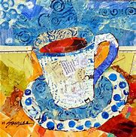  Derek Gores  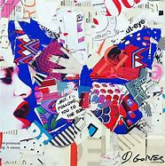
Art Skills Covered
Drawing
Collage
3D

Covering the elements of:
Pattern, texture, colour and shape.

