Year 5 Autumn 2 Forces
Learning objectives for this topic | Key vocabulary | Useful websites to search for
To explain that unsupported objects fall towards the Earth because of the force of gravity acting between the Earth and the falling object  To identify the effects of air resistance, water resistance and friction, that act between moving surfaces  To recognise that some mechanisms including levers, pulleys and gears allow a smaller force to have a greater effect | Air resistance – A force that is caused by air with the force acting in the opposite direction to an object moving through the air  Force – A push or pull upon an object resulting from its interaction with another object  Friction – The resistance that one surface or object encounters when moving over another  Gears – A toothed wheel that works with others to alter the relation between the speed of a driving mechanism (e.g. engine) and the speed of the driven parts (e.g. the wheels)  Gravity – The force that attracts a body towards the centre of the earth  Levers – A rigid bar resting on a pivot that is used to move a heavy or firmly fixed load  Mass – The weight measured by an objects acceleration under a given force or by the force exerted on it by gravity  Pull force – To draw or haul towards oneself or itself, in a particular direction  Pulleys – A wheel with a grooved rim around that changes the direction of a force applied to the cord  Push force – To move something in a specific way by exerting force  Water resistance - A force that is caused by water with the force acting in the opposite direction to an object moving through the water | - BBC KS2 Forces and Motion  - Ducksters Physics for Kids Forces  - The School Run Forces KS2
 |  | Key scientists and people
Galileo Galilei

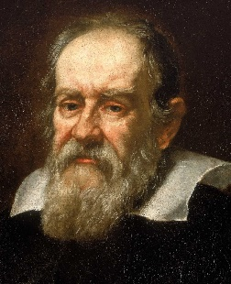

Isaac Newton
