Year 5 Autumn 2 Ancient Greeks
Learning objectives for this topic | Key vocabulary | Useful websites to search for
To identify that many English words have Greek origins.  To investigate the similarities and differences between the Greek alphabet and our alphabet today.  To identify the similarities and differences between our schools and schools in ancient Greece.  To find out about ancient Greek architecture and how it has influenced our buildings today.  To find out how ancient Greek scholars have contributed to our knowledge and understanding of the world  To be able to evaluate the contributions of the ancient Greeks to life today.  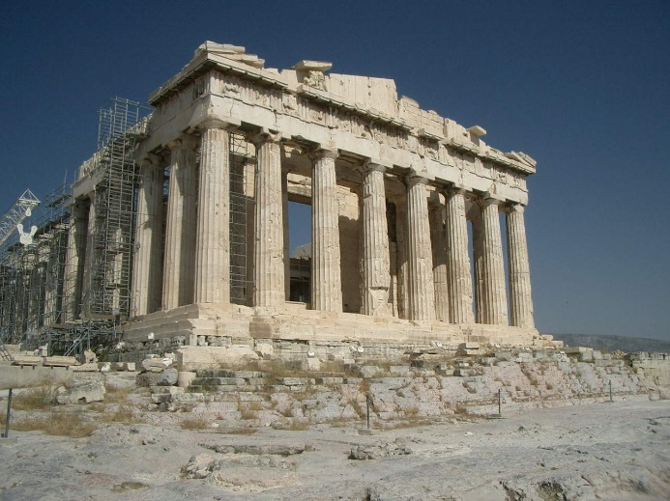 | Acropolis - An acropolis is a fortified citadel within a larger city. It is usually located on top of a hill and at the centre of the city. The most famous acropolis is the Acropolis of Athens.  Aristotle - A Greek philosopher who introduced the idea of observing and recording nature.  Assembly - In Athens the Assembly consisted of the group of citizens who showed up to vote.  Athens - One of the most powerful Greek city-states, Athens was the birthplace of democracy.  Democracy - A form of government where citizens have a say in how they are ruled including choosing their leaders and deciding on laws.  Oligarchy - A type of government where the power is held by a few people.  Olympics - An athletic event held by the Ancient Greeks every four years.  Plato - A Greek philosopher who founded the Academy in Athens and wrote many philosophical dialogues.  Polis - The Greek name for a city-state.  Socrates - A Greek philosopher who is considered to be the founder of western philosophy.  Sparta - A power Greek city-state and rival to Athens, Sparta's culture was based around warfare and preparing for battle.  Titans - The Titans were the first Greek gods. They were overthrown by their children, the Olympians.  Tyrant - The ruler of a Greek city-state, a tyrant was like a king. Today the word tyrant is used to describe a ruler who rules unfairly or unjustly. | • BBC KS2 Ancient Greeks  • Ducksters Ancient Greece for Kids  - The School Run Ancient Greeks
 |  | 