THE DIOCESE OF SHREWSBURY
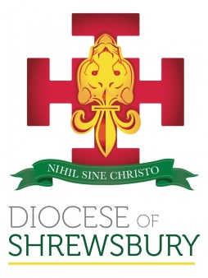

The Diocese of Shrewsbury is looking for suitably qualified practising Catholics to sit as voluntary Foundation Directors on the seven Multi Academy Trusts within the Diocese.

The existing Trusts are:
- Holy Family Catholic Academy Trust (Wirral)
- Holy Family of Nazareth Catholic Academy Trust (Macclesfield)
- The Chester Catholic Academies Partnership
- The Wythenshawe Catholic Academy Trust
- St Anselm’s Catholic Multi Academy Trust (Tameside)
- The South Cheshire Catholic Multi Academy Trust (Crewe)
- Salopia Catholic Schools Trust (Runcorn)
Potential Directors should be practising Catholics with a commitment to Catholic education and a background in a relevant discipline including education, business, law, finance and human resources.

For more information about our Multi Academy Trusts visit our website at www.dioceseofshrewsbury.org/education/academies/multi-academy-trust

To register an interest please contact sue.blackwell@dioceseofshrewsbury.org

