‘Keep Switched On’
It’s Not Okay Week of Action

18 – 24 June 2018
Parents and carers are the focus of this year’s week of action and the ‘Keep Switched On’ campaign aims to encourage them to be vigilant about their child’s safety whether they are online, or off out.
Online
Children and young people can be groomed online. Do you know what your child is doing on their phone or games console? Talk to them about what they like to do on the internet and how they can stay safe
Don’t switch off when they switch on. Regularly review security settings on your children’s online devices
The mother of a young boy who was sexually abused after being groomed on his games console has spoken out. Watch her story: https://www.youtube.com/watch?v=yCD4n3AzVzA #ItsNotOkay
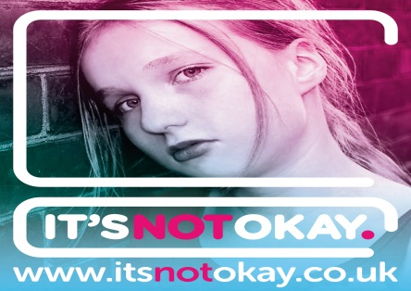
Worried your child might have been groomed online? Help is available. Visit http://www.itsnotokay.co.uk/get-help/
Encourage your child to ask for help if they see anything online that causes them concern.
Does your child really know who they’re talking to online? People might not be who they say they are
Has someone acted inappropriately towards your child online? Report it to @ceopuk #ItsNotOkay
Look at the age restrictions given to apps and games – they’re put in place to protect children, and it is really important to adhere to them
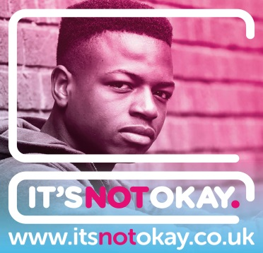
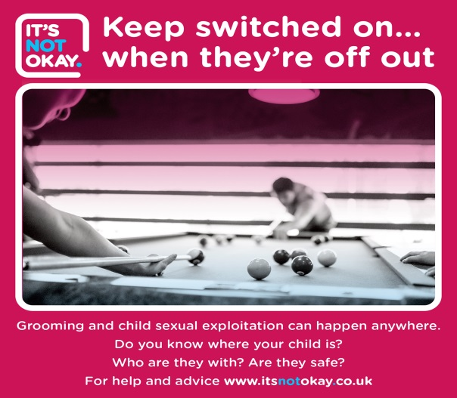
Offline
Children and young people can be groomed anywhere. Do you know how safe your child is? Where are they? Who are they with?
After school clubs and activities should have a safeguarding policy which you can ask to read. Any concerns? Please raise them
Don’t switch off when they go out. Talk to your child about where they’re going, who they’re meeting and what time they’ll be back
Child sexual exploitation can happen anywhere. Be vigilant about your child’s safety and trust your gut instinct. If something doesn’t feel right, it may not be
Concerned your child might have been groomed? Help is available. Visit: http://www.itsnotokay.co.uk/get-help/ #ItsNotOkay

General
Spot the signs of child sexual exploitation: mood swings, self-harm, bruising on arms or body, regularly using drugs or drinking alcohol, truancy or drop in performance at school, aggression towards others
Spot the signs of child sexual exploitation: change in appearance, borrowing clothes from others, always tired, unexplained relationships with older people, staying out late, not returning home, unexplained gifts
Grooming is when someone builds a connection with a young person to gain their trust for the purposes of sex abuse. This can happen online or face-to-face
Teach your child about healthy relationships. Talk through strategies to help them protect themselves if they find themselves in difficult situations. Help them learn how to keep safe #ItsNotOkay
Child sexual exploitation is never the victim’s fault. If it’s happening to you or someone you know, help is available. Report it now. Visit: http://www.itsnotokay.co.uk/get-help/ #ItsNotOkay

